Womersley solution for oscillatory flow in a straight tube

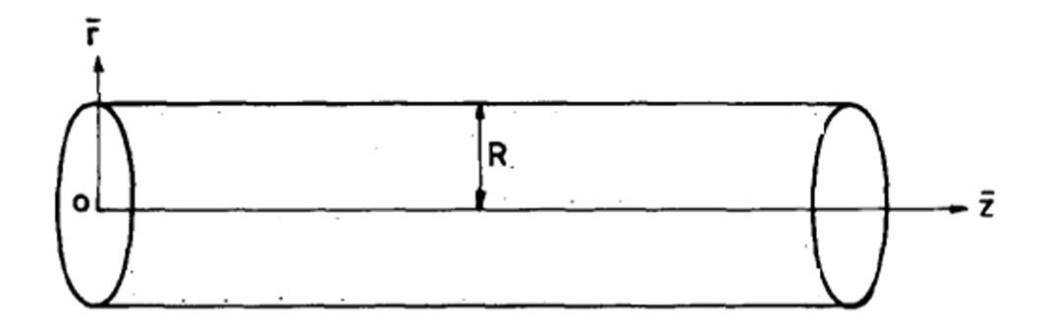Straight tube

The flow is in the axial direction and the flow is fully developed. The governing equation can be written as:
$\frac{∂ u}{∂t}=-\frac{1}{ρ}\frac{∂p}{∂z}+υ\left(\frac{1}{r}\frac{∂}{∂r}\left(r\frac{∂ u}{∂r}\right)\right) (1)$
Here, $\vec{u}$- velocity vector, t- time,$ρ$- density of fluid, $p$- pressure and $υ$ - kinematic viscosity.
With the assumption of incompressible flow and fully developed flow field, it can show that:
$$u= u\left(r, t\right)=u\left(r, t\right){\vec{e}}_{z} (2)$$
$$\frac{∂p}{∂z} =p_{z}\left(t\right) (3)$$
Equation 2 shows that the velocity field is dependent only on radial direction(r) and independent of axial direction(z). Similarly equation 3 shows that the pressure gradient is independent of space variables and only a function of time(t).

Since the flow is oscillatory, the velocity and pressure gradient can be represented in following form:
$$u\left(r,t\right)=\sum_{n=-∞}^{∞}{{\tilde{u}}_{n}\left(r\right)}e^{iw_{n}t} (4)$$
$${ p}_{z}\left(t\right)=\sum_{n=-∞}^{∞}{({{\tilde{p}}_{z})}_{n}}e^{iw_{n}t} (5)$$
Here, $w_{n}$=n.$w$ = n$\frac{2π}{T}$ ,$w$-angular frequency of oscillation, $T$-time period of oscillation and $n$-harmonic.
Equation 1 can be simplifies to:
$$\frac{∂ u}{∂t}=-\frac{1}{ρ}\frac{∂p}{∂z}+υ\left(\frac{∂^{2} u}{∂r^{2}}+ \frac{1}{r}\frac{∂ u}{∂r}\right)$$
Now the substituting eq 4 and eq 5 in the above equation:
$$iw_{n}{\tilde{u}}_{n}(r)=-\frac{1}{ρ}({{\tilde{p}}_{z})}_{n}+υ\left(\frac{d^{2}{\tilde{u}}_{n}}{dr^{2}}+ \frac{1}{r}\frac{d{\tilde{u}}_{n}}{dr}\right)$$
Rearranging the above equation
$$\frac{d^{2}{\tilde{u}}_{n}}{dr^{2}}+\frac{1}{r}\frac{d{\tilde{u}}_{n}}{dr}-\frac{iw_{n}{\tilde{u}}_{n}}{ν}=\frac{1}{νρ}({{\tilde{p}}_{z})}_{n} (6)$$
This is a modified Bessel differential equation. Taking $K_{n}^{2}= \frac{iw_{n}}{ν}$
so, the equation 6 becomes:
$$\frac{d^{2}{\tilde{u}}_{n}}{dr^{2}}+\frac{1}{r}\frac{d{\tilde{u}}_{n}}{dr}-K_{n}^{2}{\tilde{u}}_{n}=\frac{1}{νρ}({{\tilde{p}}_{z})}_{n}$$
The general solution to above equation is:
$${\tilde{u}}_{n}\left(r\right)=A_{n}J_{o}\left(K_{n}r\right)+ B_{n}Y_{o}\left(K_{n}r\right)+\frac{\left({\tilde{p}}_{z}\right)}{iw_{n}ρ} (7)$$

Applying BCs,
At n=0, r=0,$Y_{o}=0$
At r=R, ${\tilde{u}}_{n}\left(r\right)=0$

$$0=A_{n}J_{o}\left(K_{n}R\right)+\frac{({\tilde{p}}_{z})}{iw_{n}ρ}$$
$$A_{n}=-\frac{({\tilde{p}}_{z})}{iw_{n}ρJ_{o}\left(K_{n}R\right)}$$
Substituting back:
$${\tilde{u}}_{n}\left(r\right)=-\frac{({\tilde{p}}_{z})}{iw_{n}ρJ_{o}\left(K_{n}R\right)}J_{o}\left(K_{n}r\right)+\frac{({\tilde{p}}_{z})}{iw_{n}ρ}$$
$${\tilde{u}}_{n}\left(r\right)=\frac{({\tilde{p}}_{z})}{iw_{n}ρ}\left(1-\frac{J_{o}\left(K_{n}r\right)}{J_{o}\left(K_{n}R\right)}\right)$$
To express this in terms of the centerline velocity ${\tilde{U}}_{n}$, we evaluate at r=0
$${\tilde{U}}_{n}={\tilde{u}}_{n}\left(0\right)=\frac{({\tilde{p}}_{z})}{iw_{n}ρ}\left(1-\frac{J_{o}\left(0\right)}{J_{o}\left(K_{n}R\right)}\right)$$
$${\tilde{U}}_{n}={\tilde{u}}_{n}\left(0\right)=\frac{({\tilde{p}}_{z})}{iw_{n}ρ}\left(1-\frac{1}{J_{o}\left(K_{n}R\right)}\right)$$

Substituting back into the expression

$${\tilde{u}}_{n}\left(r\right)={\tilde{U}}_{n}\left(\frac{1-J_{o}\left(K_{n}r\right)/J_{o}\left(K_{n}R\right)}{1-1/J_{o}\left(K_{n}R\right)}\right)$$
Here $K_{n}=\sqrt{iw_{n}/υ}$, $i=\sqrt{-1}$, $J_{o}$=Bessel function of first kind of order zero, r=any radial position and R=radius of the tube.

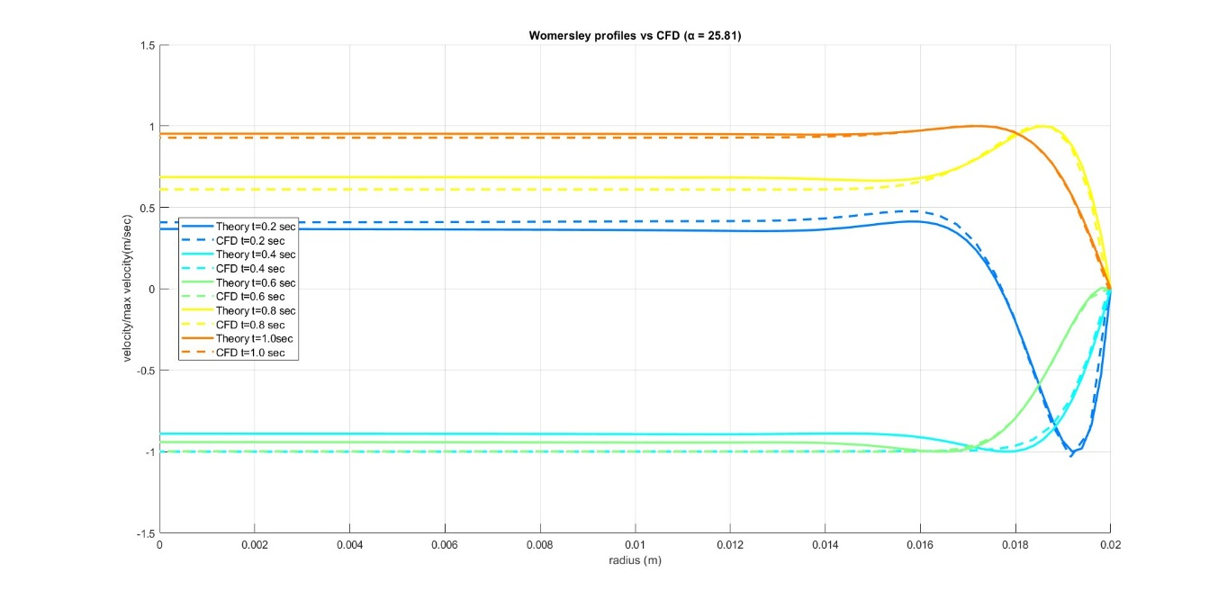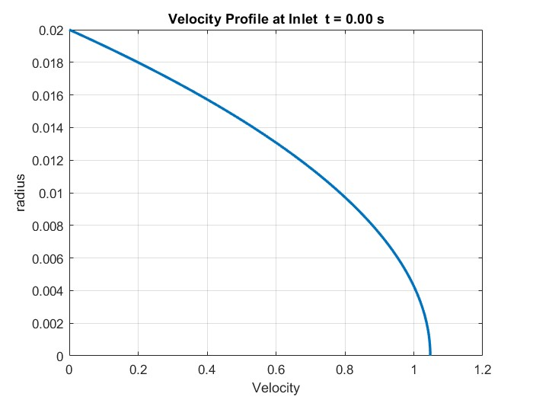

Matlab Script
